|  |
| --- |
| **Lab01: Getting started with Netbeans** |

Introduction to:

|  |
| --- |
| 1. Netbeans IDE 2. Exercises |

|  |
| --- |
| **Exercises** |

Exercise 1

Create a new java project on NetBeans named as “First_Exercise”. Display a text message saying, “This is my first program”. Provide multiline document string for the created program explaining the process in the program

Source Code:

package first_exercise;

public class First_Exercise {

public static void main(String[] args) {

System.out.println("This is my first program");

}

}

Output:

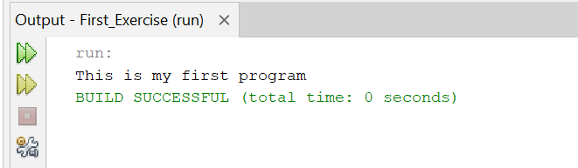

Exercise 2

Create a java program named “Second_Exercise”. Print the name, enrollment, Subject name, Instructor name and semester of a student and attach proper output screen shot. Provide proper comments.

**Expected Output:**

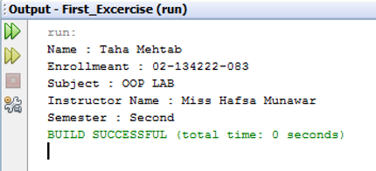

**NOTE: Provide proper comments to each line of code**

**Source Code:**

package second_exercise;

public class Second_Exercise {

public static void main(String[] args) {

// Declare and initialize student details

String Name = "Ayman Khan";

String enrollment = "02-134241-024";

String subject = "Object-Oriented Programming";

String instructor = "Syed Osama Ali";

String semester = "2nd Semester";

// Print student details

System.out.println("Student Name: " + Name);

System.out.println("Enrollment Number: " + enrollment);

System.out.println("Subject Name: " + subject);

System.out.println("Instructor Name: " + instructor);

System.out.println("Semester: " + semester);

}

}

**Output:**

